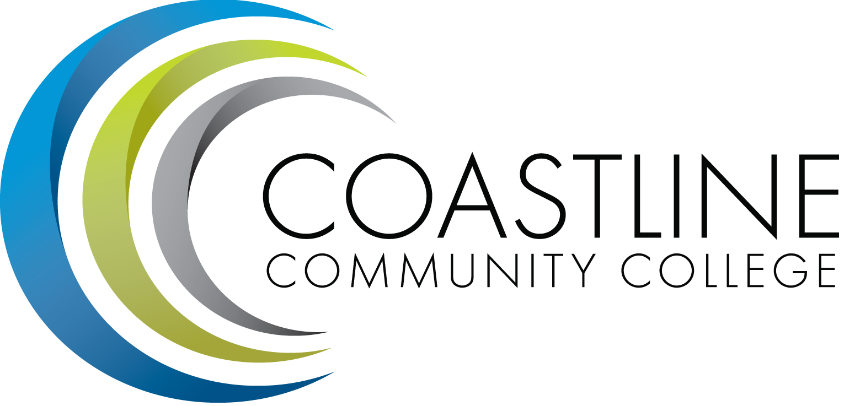

College Professional Development & Leadership Committee Agenda
09/06/2016
3:00 pm to 5:00 pm
College Center, Distance Learning Conference Room

Committee Mandate: To promote, coordinate, recommend, and support the creation and delivery of professional development and leadership programs that increase the effectiveness of our institution and the satisfaction of our employees.

- CALL TO ORDER
  - Roll Call

Present | Members
 | Bob Nash, Co-chair, Associate Dean, Distance Learning
 | Cheryl Chapman, Co-chair, Faculty Senate Representative
 | Judy Garvey, CMT Representative
 | Elaine Hill, Classified Representative
 | Ken Leighton, Faculty Representative
 | Dorothy McCollom, Classified Representative & Committee Support
 | Renate Akins,
 | Randall Warwick, Faculty Representative
 | Aeron Zentner, CMT Representative

  - Welcome
  - Adoption of Agenda
  - Approval of Minutes: 05/03/2016

- SPECIAL REPORTS & UPDATES
  - 2016 Summer Institute (Bob)

- ACTION ITEMS
  - None

- STANDING REPORTS
  - None

- DISCUSSION ITEMS
5.1 Membership in Online Learning Consortium (Bob)
5.2 Grovo (Cheryl)
5.3 Renewing Innovative Educators/Go2Knowledge License (Bob)
5.4 Renewing ITC Membership (Bob)
5.5 Cornerstone LMS (Renate)

- ANNOUNCEMENTS (1-2 minutes per)
6.1 Next Meeting, October 4, 2016 at 3:00 pm

- ADJOURNMENT

